**EDUCATIONAL INITIATIVES**

**Exercise 2 problems**

**Github link:** <https://github.com/Yoga-naga/Education_Initatives_exercise.git>

1. **Astronaut Daily Schedule Organizer Programming Exercise**

**OUTPUT:**

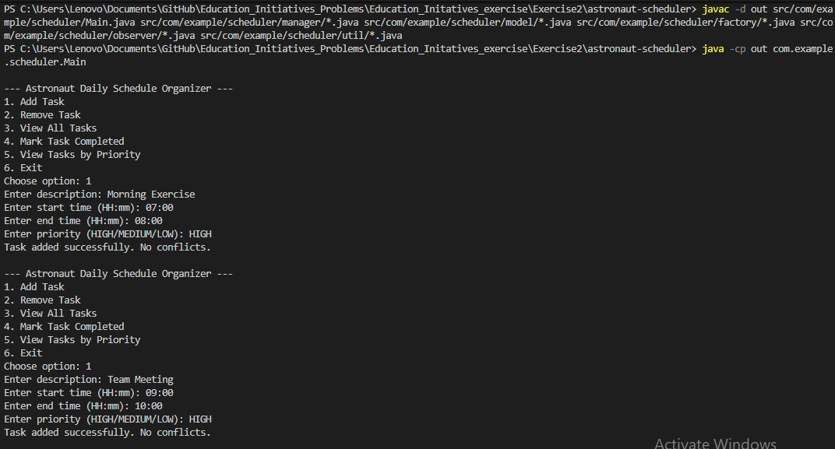

**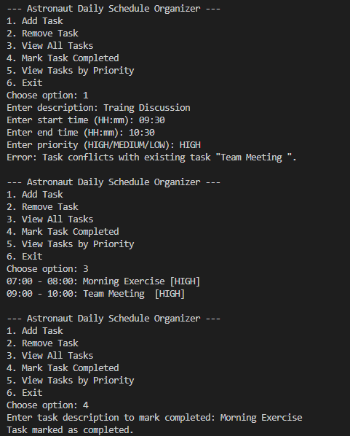  
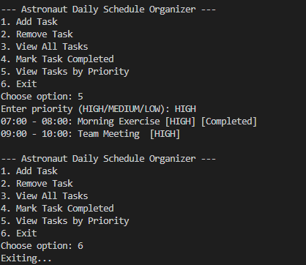**

1. **Smart Office Facility Programming Exercise**

**OUTPUT:**



